Our project focuses on scaling monocular ORB_SLAM during initialization using a metric sensor, downward facing IR.

ORB_SLAM initializes with either Homography or Fundamental. Since both the methods are correct up-to scale, we are extracting the translation vector from the two matrices and scaling it using the metric information from IR. We have implemented both the Homography and Fundamental matrices and extracted the translation vector from it. However, in our preliminary tests, the triangulated 3d points don’t look right and the translation vector makes sense but isn’t scaling properly. Figure 1 shows the feature matches used to extract the fundamental then the essential matrix ($E=K^{T}FK$).

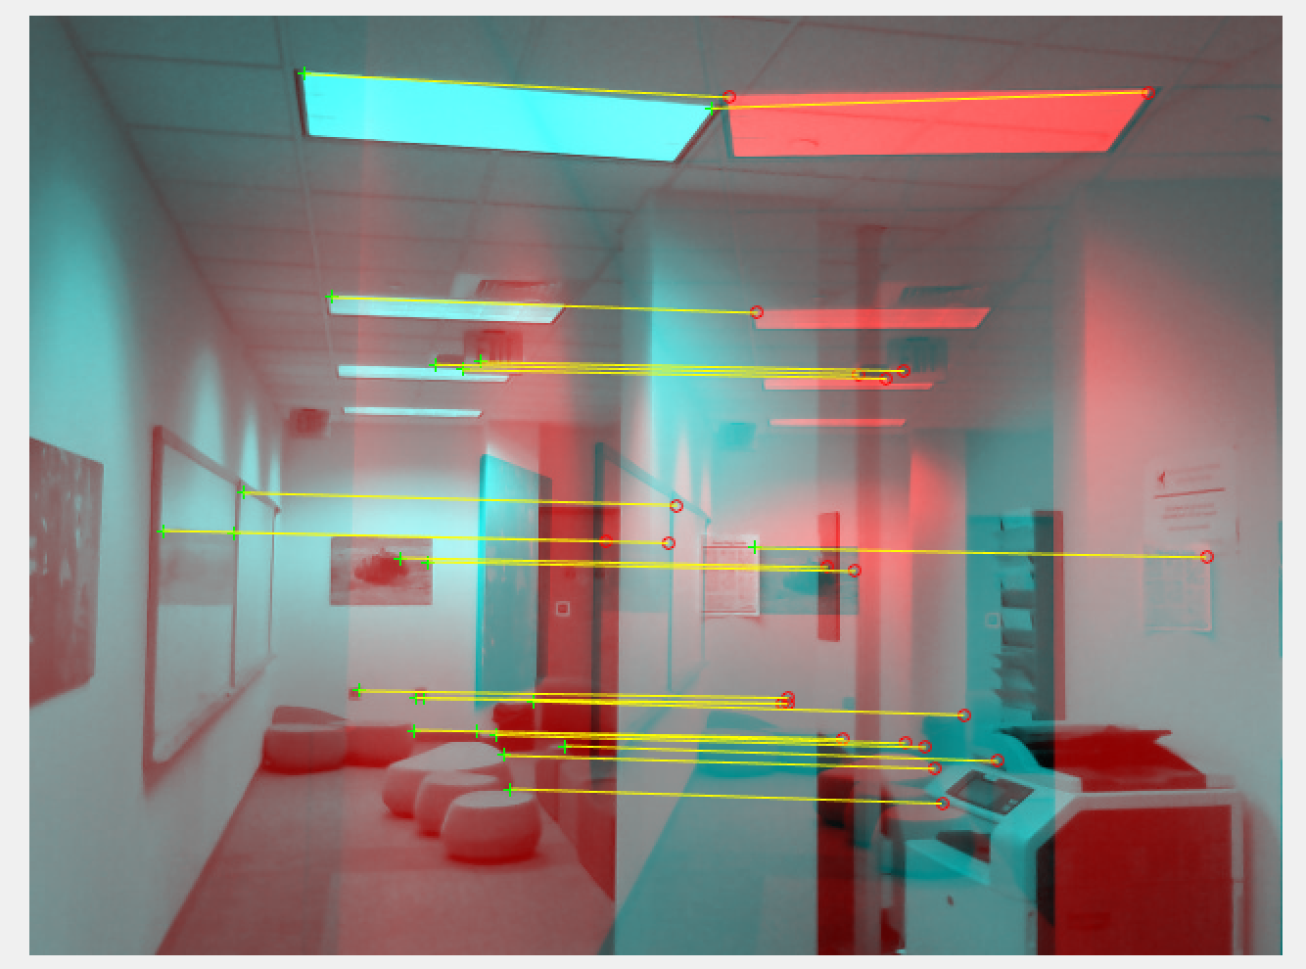

Figure : Feature Matches

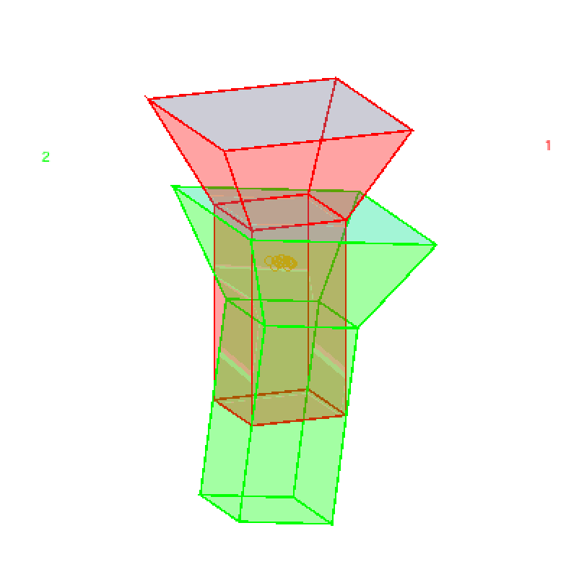When extracting rotation and translation from the essential matrix, there are four potential transformations, neither of which makes sense. Although the relative motion of the camera makes sense, when triangulated, the points are bizarre. As shown in Figure 2, the relative camera motion makes sensor, but the points aren’t being triangulated correctly. Similar problems exist in the homography case.

Figure : Relative Camera motion with triangulated points